**Number Detection from Finger Gestures Using Machine Learning**

**ARAVIND M J**

(aravindmj97@gmail.com)

*Machine Learning through Python, ICFOSS*

June 2021

Contents

List of Figures 2

ABSTRACT 3

Implementation 4

Libraries Used 4

Process 4

Screenshots 5

Conclusion 7

Code 7

# List of Figures

Figure 1: Hand Coordinates 4

Figure 2: Detects Number 5 5

Figure 3 : Detects Number 2 5

Figure 4 : Detects 0 as no fingers are raised 5

Figure 5 : Drawing after pressing the pencil icon 6

Figure 6 : Drawing erased on pressing the eraser icon 6

# ABSTRACT

In the current situation of virtual classrooms, there is an immense opportunity for interactive online classes. By leveraging the power of technology and various algorithms in machine learning, the online classes can be made more interactive. This topic takes in account the various possibilities of using hand gestures in online classes. As an initiative to this, I will be using machine learning techniques to detect the number that the user shows through their hands and the system will predict the number shown. Various image processing techniques might be required in this implementation. I believe doing this project will improve my knowledge in this area and motivate me to pursue on more topics.

# Implementation

## Libraries Used

* OpenCV
* Mediapipe

## Process

The video stream from the web cam is fed to the mediapipe hands api. This will process the images and return the coordinates of various points on the palm. This information is then used to write the logic for determining the number shown in the hand and then for the writing and erasing operation.

The mediapipe hands api has a [Palm Detection Model](https://google.github.io/mediapipe/solutions/hands#palm-detection-model) that finds the position of the hand in the image. This is then passed to the [Hand Landmark Model](https://google.github.io/mediapipe/solutions/hands#hand-landmark-model) when then finds the coordinates of various points on the hand.

[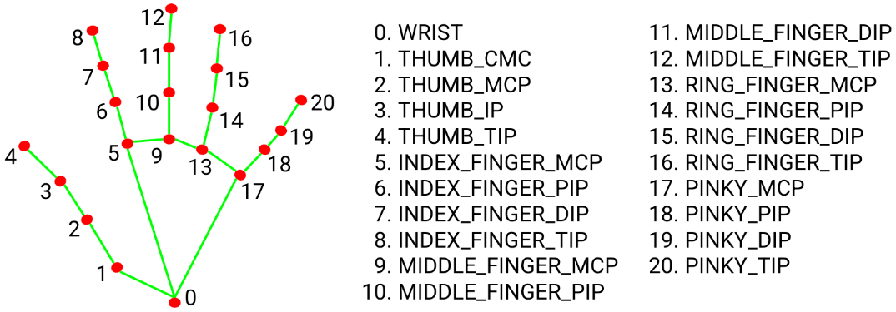](https://google.github.io/mediapipe/solutions/hands#hand-landmark-model)

Figure 1: Hand Coordinates

The important functions and their uses are mentioned below:

1. findHandPoints – Calls the mediapipe hands api and returns coordinates
2. findTheNumberSet – Creates an array of 0’s and 1’s corresponding to the number of fingers raised
3. checkIfInEditMode – Does the check to see if the user pressed the edit button on the screen
4. clearPoints – Does the check to see if the user pressed the erase button on the screen

# Screenshots

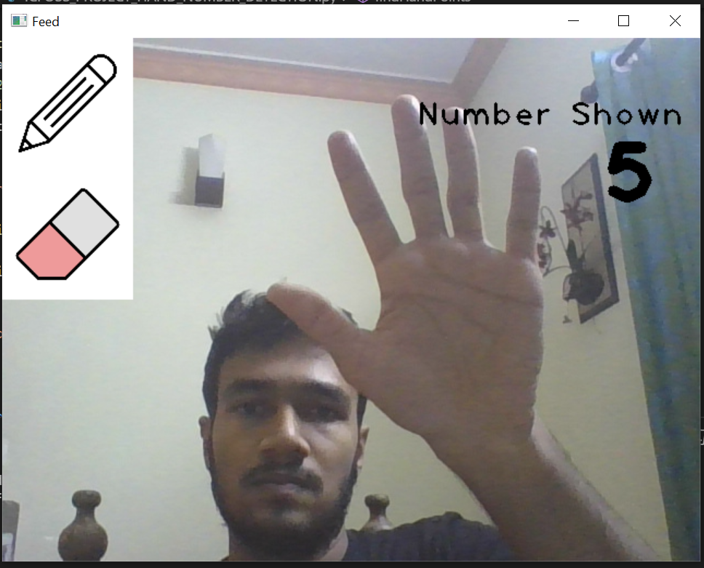

Figure 2: Detects Number 5

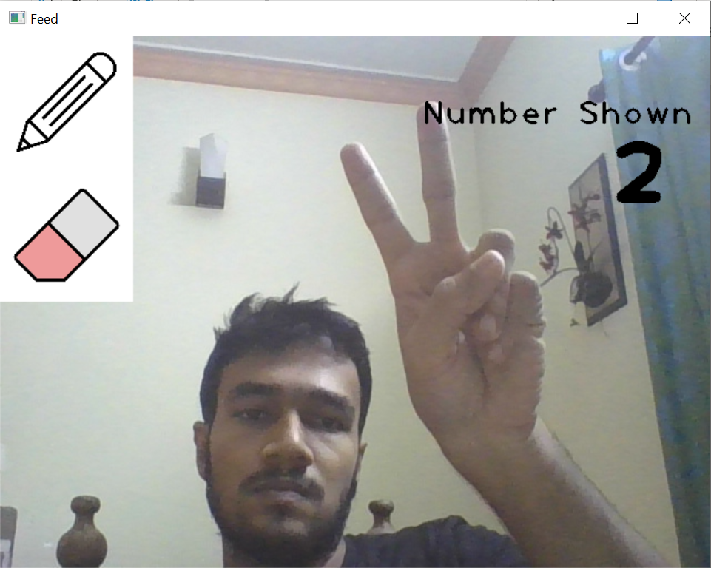

Figure 3 : Detects Number 2

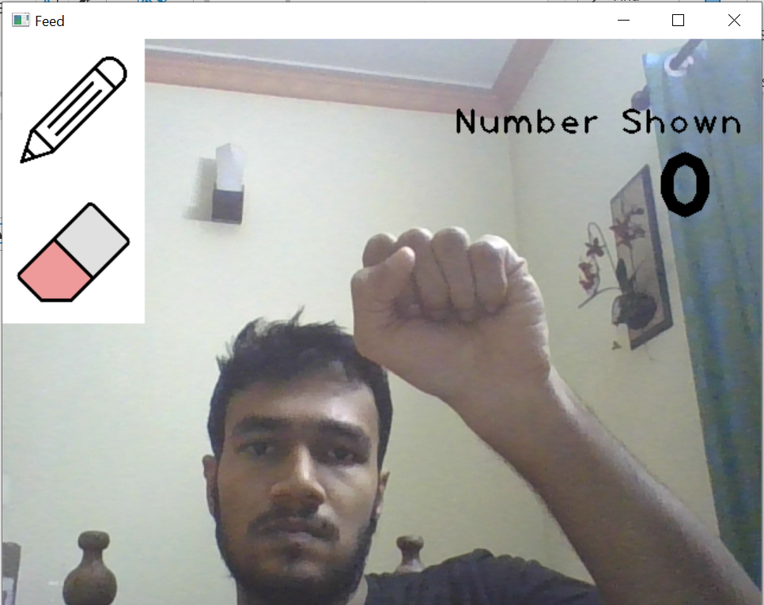

Figure 4 : Detects 0 as no fingers are raised

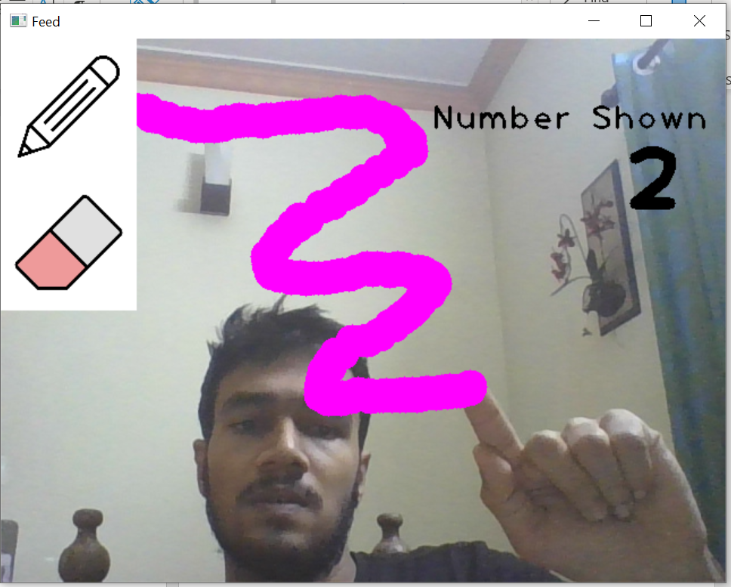

Figure 5 : Drawing after pressing the pencil icon

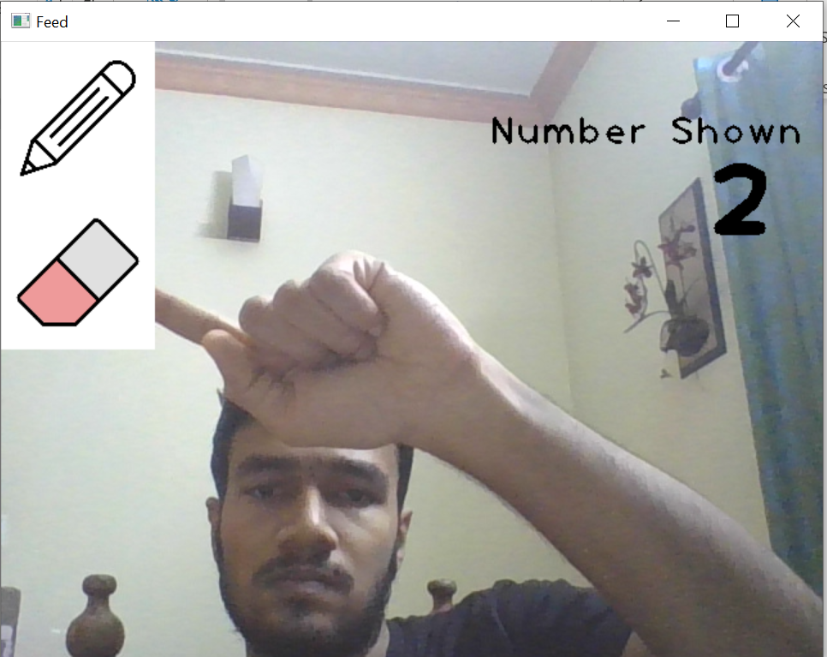

Figure 6 : Drawing erased on pressing the eraser icon

# Conclusion

The project has been done successfully in the stipulated time frame. The project will be as an initial step towards building an interactive online teaching platform or any other similar use cases.

# Code

Github - https://github.com/aravindmj97/ICFOSS-Final-Project---Hand-Number-Detection